CHAROTAR UNIVERSITY OF SCIENCE AND TECHNOLOGY
FACULTY OF TECHNOLOGY AND ENGINEERING
CHANDUBHAI S. PATEL INSTITUTE OF TECHNOLOGY
OCCE4001 - SOFTWARE TESTING

PRACTICAL LIST – AY: 2026- 27
Sr. no. | Title | CO/PO
2. | Title: Web and API Testing using Selenium WebDriver and Postman  Aim: To perform functional testing of a web application using Selenium WebDriver and validate REST APIs using Postman.  Software/Tools Required  - Selenium WebDriver  - Google Chrome  - Chrome Driver  - Postman  - Internet Connection  Procedure  - Install Selenium WebDriver and Chrome Driver.  - Launch the selected web application.  - Automate user actions such as login, navigation, and form submission using Selenium.  - Verify the expected outputs using assertions.  - Open Postman.  - Send GET and POST requests to the selected REST API.  - Validate status code, response body, response time, and headers.  - Record the observations.  Expected Outcome: Successful execution of UI automation scripts and API validation.  Result: The functionality of the web application and REST APIs was successfully tested. | CO4 / PO1, PO2, PO3, PO5 and PO12
Solution:
1) Check python in system , “python --version” , “python3 --version”
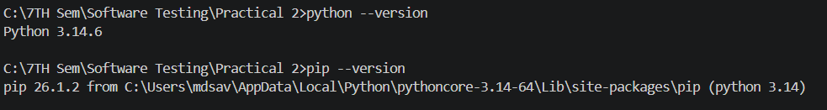
2) run command “pip3 install selenium”
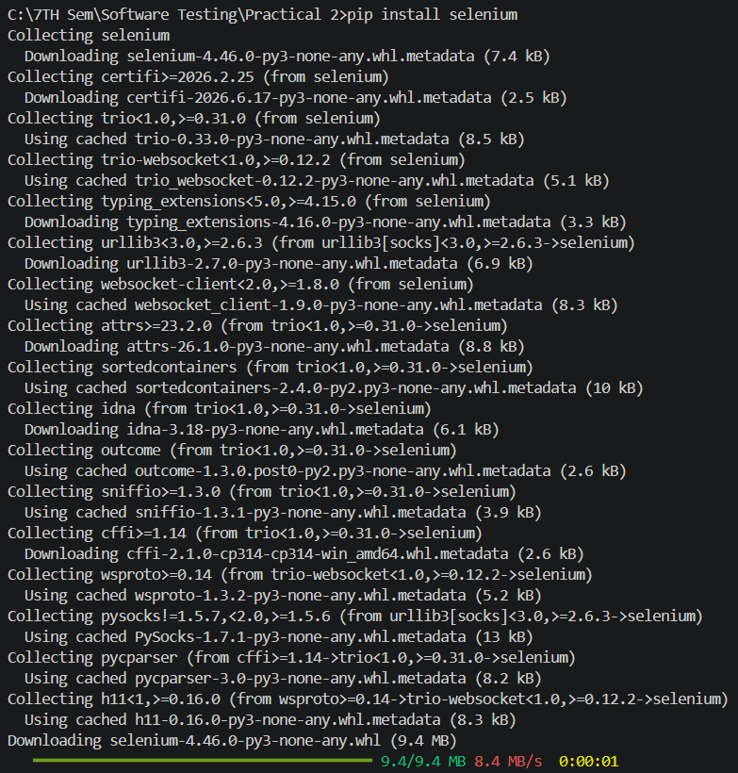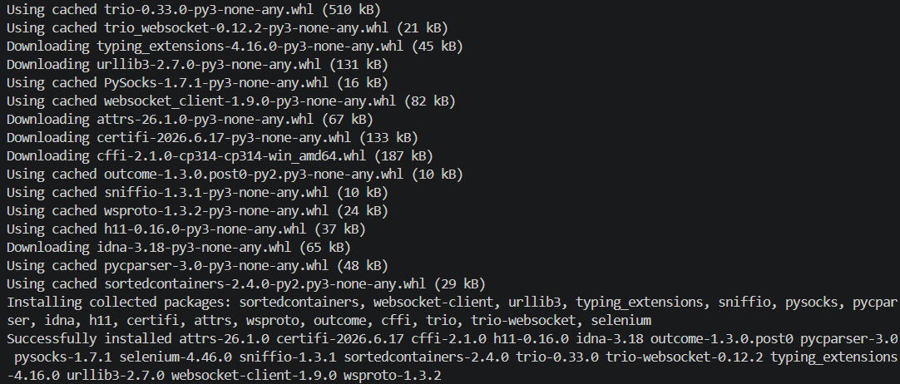

3)Open IDE and make “login_test.py”
4) write script

from selenium import webdriver
from selenium.webdriver.common.by import By
import time

# Launch the browser
driver = webdriver.Chrome()
driver.implicitly_wait(10)

# Open the website
driver.get("https://www.saucedemo.com")

# Fill in the login fields
driver.find_element(By.ID, "user-name").send_keys("standard_user")
driver.find_element(By.ID, "password").send_keys("secret_sauce")
driver.find_element(By.ID, "login-button").click()

time.sleep(2) # wait for the page to load

# Assertion - verify login successful
title = driver.title
print("Page Title:", title)

try:
logo = driver.find_element(By.CLASS_NAME, "app_logo")
if logo.is_displayed():
print("Login Test Passed - Assertion Successful")
except:
print("Login Test Failed")

driver.quit()

5) Run python file “python3 login_test.py” and check Output .
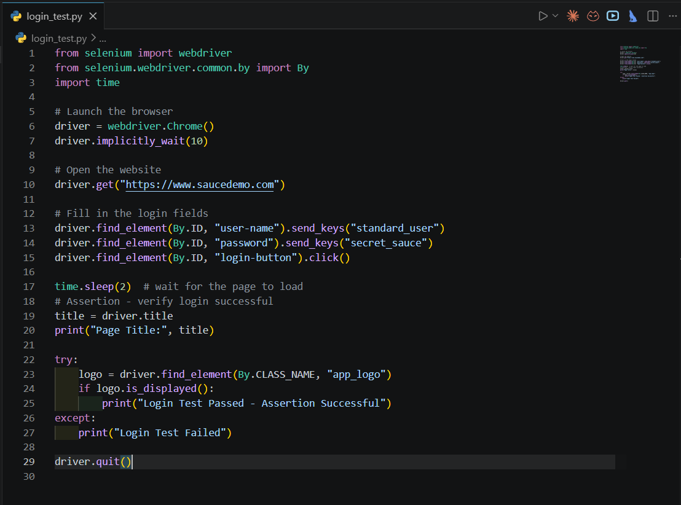
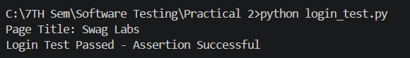

1.2) Download Postman ,install and Open.
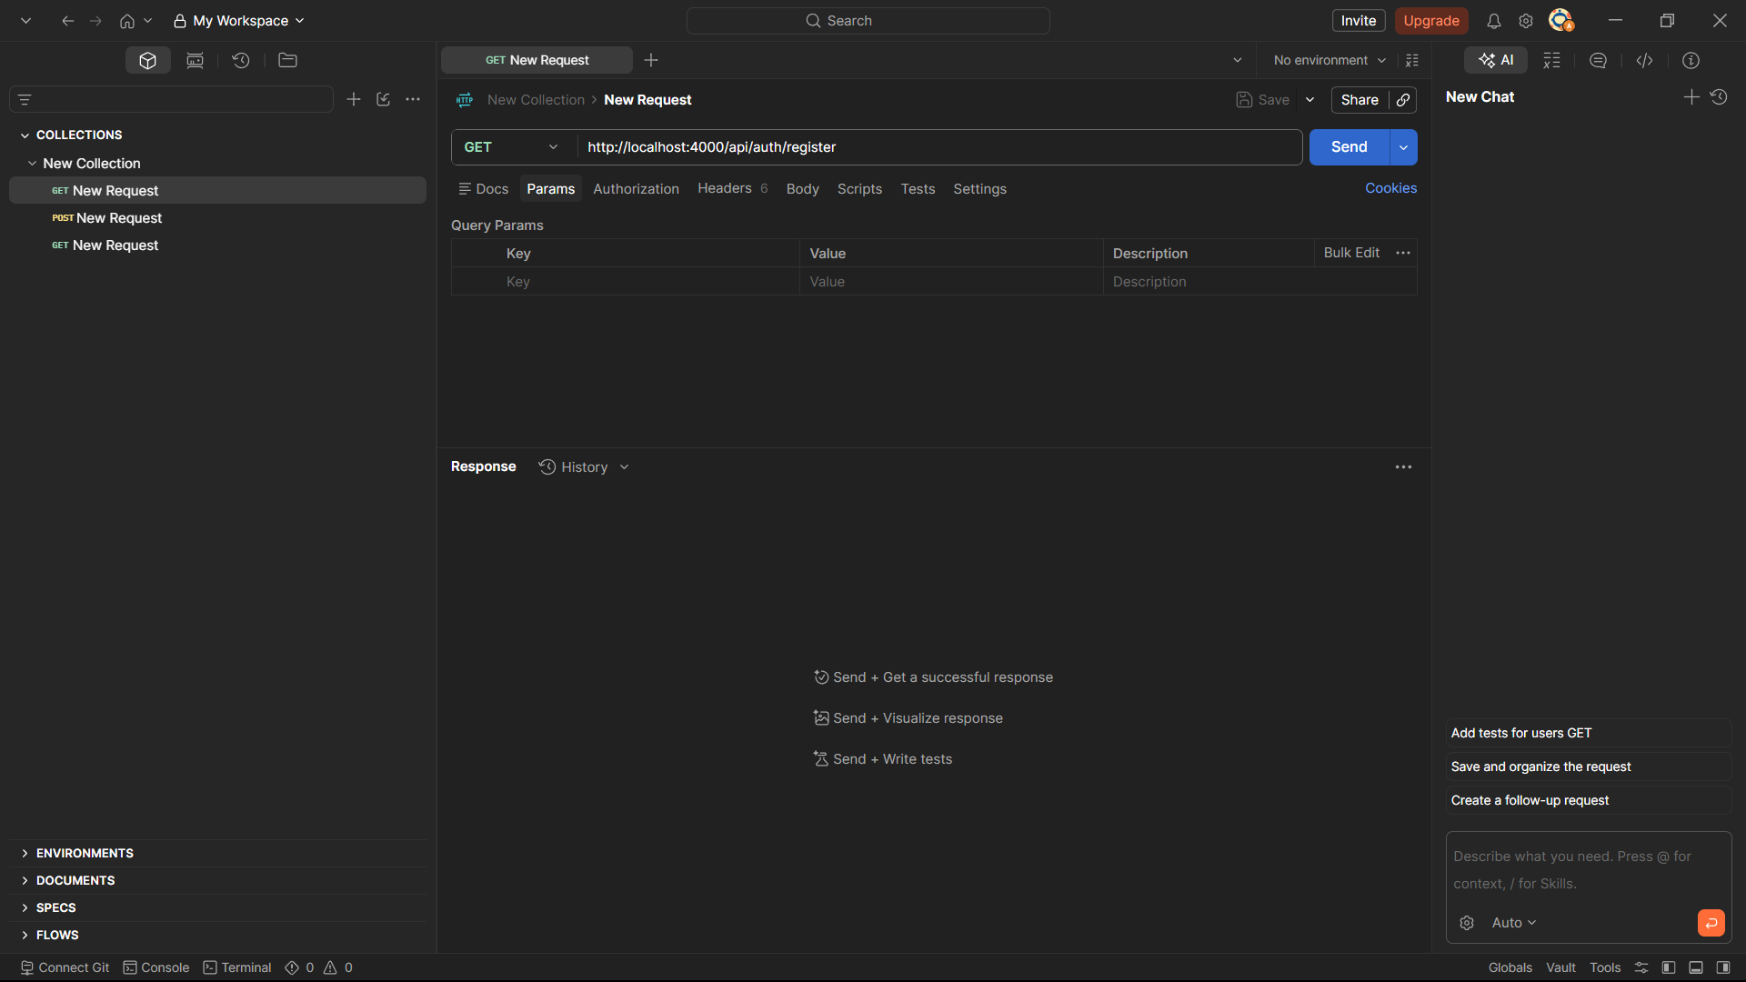

2) Select Get Request for url “https://jsonplaceholder.typicode.com/users”
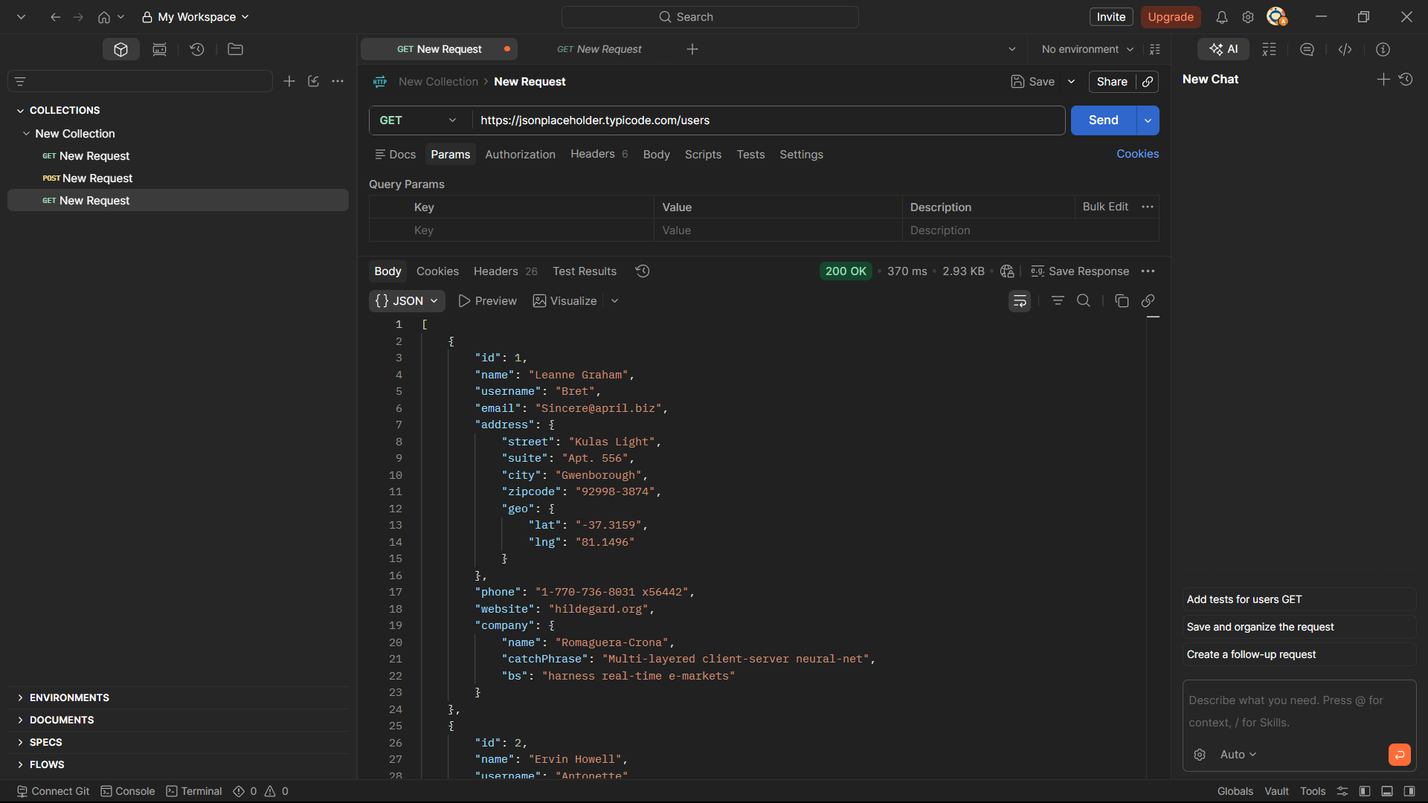

3)Select Post request “https://jsonplaceholder.typicode.com/posts”
Body → raw → JSON :

{
"title": "abc",
"body": "Software Testing Practical",
"userId": 1
}
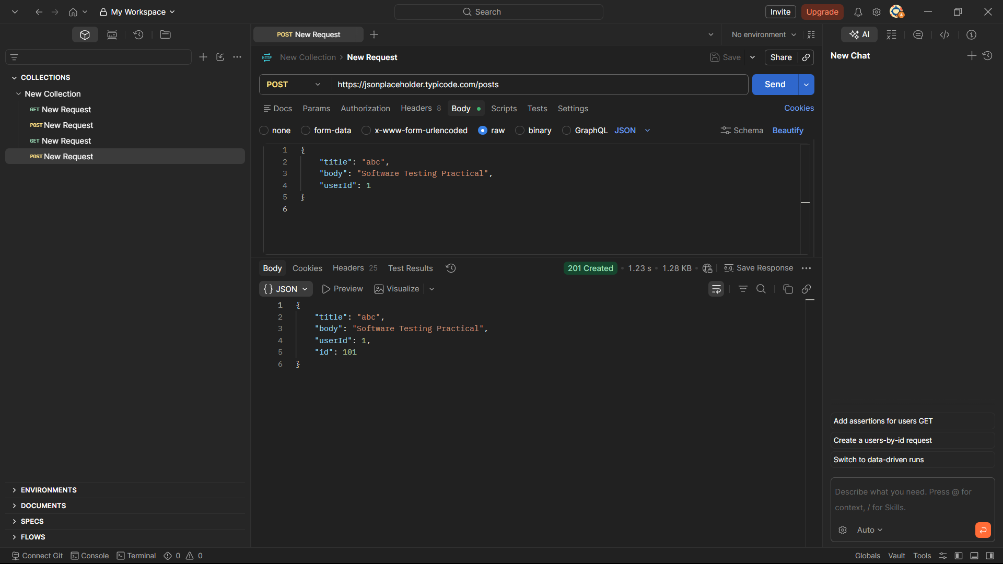
Reference Youtube Video:
https://www.youtube.com/watch?v=YEhnSrdLcHE

